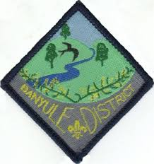

# **Banyule Cub Scouts’** part in our **State Synchronised Campfire** evening

# For an evening of Songs & Skits

With Cubs from around the District & State getting together, an evening & making our own fun.

This is part of this year’s theme of getting back to our Traditions.

Where: Bundoora Scout Hall

20 Noorong Ave

Bundoora

When: Saturday 24th August

Cub drop off: 6.15 p.m. for a 6.30 p.m. start

Cub pickup: 8.00 p.m.

## Please bring: Cub Uniform, Scarf & clothing suitable for the weather conditions – coat etc. (if it’s raining we’ll be inside the Bundoora Scout Hall) & something to sit on such as a Yoga mat or towel

Water bottle

Sense of fun!

Song & Skit’s for the night will be provided.

RSVP: Tuesday 20th August to your Pack Akela/Cub Scout Leader

Yours In Scouting

Pete Owens

DLCS – Banyule

Mb 0408 323 083